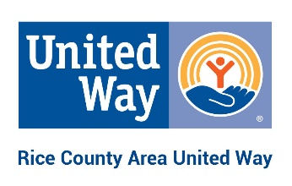

**CAMPAIGN COORDINATOR’S GUIDE**

**Plan**

* Recruit and meet with Campaign Committee
* Determine dates of campaign
* Make a campaign timeline
* Set a goal – participation goals make it easy for everyone to join in
* Set a budget for incentives, food, etc.

**Launch**

* CEO letter/email to all employees encouraging participation
* United Way launch (consider offering food! Donuts, dessert?)
* Announce what’s new with the campaign
* Announce why this year’s campaign matters (see 8 Reasons to Give to United Way; our Partner Impact Report, our pledge-brochure)
* Host a nonprofit leader (United Way can help you) for a 5-minute presentation about why United Way matters
* Put up posters

**Keep the campaign fun**

* Offer incentives such as a raffle for a day off, parking space or lunch with the CEO
* Hold a silent auction in which employees and company offer gifts and services to bid on with $ going to the campaign
* Play our Triva Game (see in Workplace Online)
* Have a leader who’s supportive? Ask him or her to agree to dress up (superhero, Halloween character or other) or kiss a pig(!) if you make goal!
* Ask for company funds for other prizes
* Employees get chances for prizes for:
  + Turning in pledge/give form
  + Participating at a certain level
* Raffle off items or experiences donated by staff – Money goes to United Way
* Create competitions between departments for turning in the most pledge forms or raising the most money

**Final push**

* Let employees know how much you have left to meet goal
* Save a good incentive for a last push
* Send one more note to employees

**Thank donors**

* Personal notes are the best – in a timely manner
* Ask your CEO to sign thank you notes
* Create a Thank You Donors! Banner (Walgreens is especially affordable)

**Show the impact of donations**

* Ask employees to “like” us on Facebook (United Way – Rice County) or sign up for our e-newsletter (www.ricecountyunitedway.org) to get updates
* Announce final company participation or giving total

Thank you for your critical role as campaign coordinator. This campaign could not succeed without you!

Elizabeth Child, Executive Director

507-664-3510

[elizabeth@ricecountyunitedway.org](mailto:elizabeth@ricecountyunitedway.org)

“Our employees look forward to our campaign all year long because it is so much fun!” – Patti Quilling, Vice President, Community Resource Bank